AI Spam Email Detector
An End-to-End AI Solution for Cybersecurity

1. Introduction
This project develops an AI-powered spam email detection system that helps identify malicious and unwanted emails using machine learning techniques. The system improves cybersecurity by automatically filtering suspicious messages before they reach the user, reducing exposure to phishing attempts, scams, and malware.

2. Problem Statement
Spam and phishing emails pose major cybersecurity threats to individuals and organizations. Traditional rule-based filtering methods are not always effective against modern, constantly evolving spam techniques. Millions of malicious emails are sent every day, leading to stolen credentials, financial loss, and data breaches.

3. Objectives
- Detect spam emails automatically using machine learning.
- Improve overall email and account security.
- Reduce successful phishing attacks and scams.
- Demonstrate the practical application of AI in cybersecurity.

4. Technologies Used
- Python — core programming language for the AI model.
- Scikit-learn — Machine Learning library (Naive Bayes classifier).
- Natural Language Processing (NLP) — text preprocessing and tokenization.
- CountVectorizer — converts text into numerical feature vectors.
- React + TypeScript — modern web interface for the prototype.

5. AI Workflow
Email Input → Text Processing → AI Model Analysis → Spam Prediction → Result Displayed
The user submits an email message. The text is cleaned and tokenized, then converted into numerical features. A trained Naive Bayes model predicts the probability that the message is spam, and the result is shown to the user.

6. Use Case Diagram
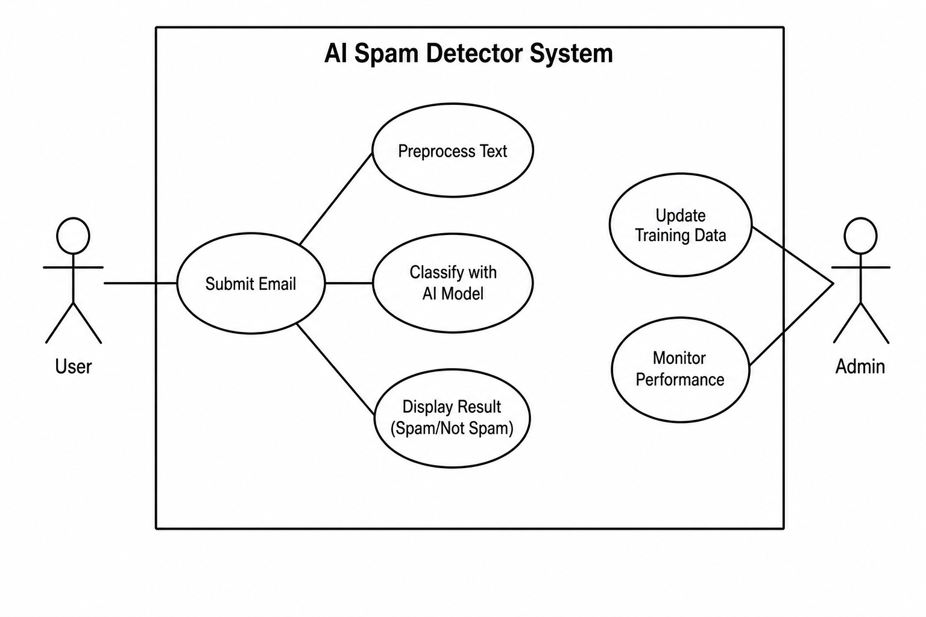

7. Functional Prototype (Python)
Below is a beginner-friendly working AI spam detector. Save as spam_detector.py.
from sklearn.feature_extraction.text import CountVectorizer
from sklearn.naive_bayes import MultinomialNB
emails = [
"Win money now",
"Limited time offer",
"Claim your free prize",
"Meeting at 2pm tomorrow",
"Project discussion update",
"Lunch plans today"
]
labels = [1, 1, 1, 0, 0, 0] # 1 = spam, 0 = not spam
vectorizer = CountVectorizer()
X = vectorizer.fit_transform(emails)
model = MultinomialNB()
model.fit(X, labels)
user_email = input("Enter an email message: ")
user_data = vectorizer.transform([user_email])
prediction = model.predict(user_data)
if prediction[0] == 1:
print("This email is SPAM")
else:
print("This email is NOT SPAM")

8. Week 4 — Improvements & Future Work
- Add a graphical user interface (GUI) for non-technical users.
- Use real, large-scale email datasets (e.g. Enron, SpamAssassin).
- Improve model accuracy with TF-IDF and ensemble methods.
- Detect phishing links via URL analysis and domain reputation.
- Connect to real email services (Gmail/Outlook APIs) for live filtering.

9. Conclusion
The AI Spam Email Detector demonstrates how machine learning can solve a real-world cybersecurity problem. By automatically identifying suspicious messages, it protects users from phishing, scams, and malware — making digital communication safer for everyone.

